Practical-8: Intermediate Programs Using Pointer

1) | Swap value of two numbers using pointer. (A)
Program :-
#include <stdio.h>
void main(){
int n1,n2;
printf("Enter the First Number : ");
scanf("%d",&n1);
printf("Enter the Second Number : ");
scanf("%d",&n2);
int *ptr1 = &n1;
int *ptr2 = &n2;
int temp = *ptr1;
*ptr1 = *ptr2;
*ptr2 = temp;
printf("n1 = %d\n",n1);
printf("n2 = %d\n",n2);
}
 | Output :-
 | 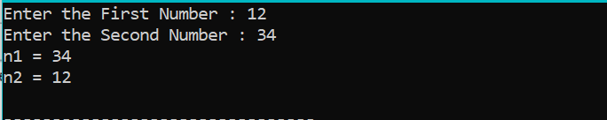
2) | Store n elements in an array and print the elements using pointer.(A)
 | Program :-
#include <stdio.h>
void main(){
int n = 0,i = 0;
printf("Enter the Size of Array : ");
scanf("%d",&n);
int arr[n];
for(i=0;i<n;i++){
printf("Enter the value at Index %d :",i);
scanf("%d",&arr[i]);
}
//Print Array
printf("\nArray : \n");
int *ptr = arr;
for(i=0;i<n;i++){
printf("%d ",*(ptr+i));
}
}
 | Output :-
 | 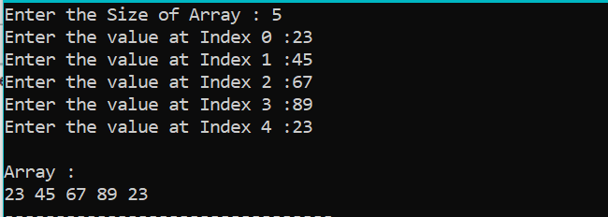
3) | Find even and odd numbers in array using pointer. (A)
 | Program :-
#include <stdio.h>
void main(){
int n = 0,i = 0;
printf("Enter the Size of Array : ");
scanf("%d",&n);
int arr[n];
for(i=0;i<n;i++){
printf("Enter the value at Index %d :",i);
scanf("%d",&arr[i]);
}
int *ptr = arr;
//Print Even Numbers
printf("\nEven Numbers : \n");
for(i=0;i<n;i++){
if( *(ptr+i)%2 == 0){
printf("%d ",*(ptr+i));
}
}
//Print Odd Numbers
printf("\nOdd Numbers : \n");
for(i=0;i<n;i++){
if( *(ptr+i)%2 != 0){
printf("%d ",*(ptr+i));
}
}
}

 | Output :-
 | 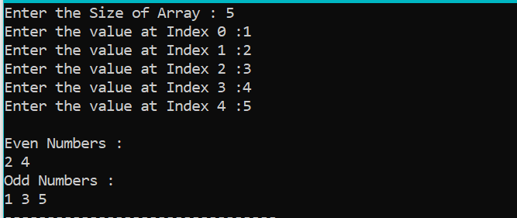
4) | Print positive and negative numbers in array using pointers. (A)
 | Program :-
#include <stdio.h>
void main(){
int n = 0,i = 0;
printf("Enter the Size of Array : ");
scanf("%d",&n);
int arr[n];
for(i=0;i<n;i++){
printf("Enter the value at Index %d :",i);
scanf("%d",&arr[i]);
}
int *ptr = arr;
//Print Positive Numbers
printf("\nPositive Numbers : \n");
for(i=0;i<n;i++){
if( *(ptr+i) >= 0){
printf("%d ",*(ptr+i));
}
}
//Print Negative Numbers
printf("\nNegative Numbers : \n");
for(i=0;i<n;i++){
if( *(ptr+i) < 0){
printf("%d ",*(ptr+i));
}
}
}

 | Output :-
 | 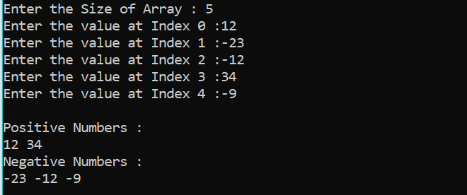
5) | Sort array using pointers.(B)
 | Program :-
#include <stdio.h>
void main(){
int n = 0,i = 0,j = 0;
printf("Enter the Size of Array : ");
scanf("%d",&n);
int arr[n];
for(i=0;i<n;i++){
printf("Enter the value at Index %d :",i);
scanf("%d",&arr[i]);
}
//Sort Array By Selection Sort
int *ptr = arr;
int minIdx = 0,temp = 0;
for(i=0;i<n-1;i++){
minIdx = i;
for(j=i+1;j<n;j++){
if(*(ptr+j) < *(ptr+minIdx)){
minIdx = j;
}
}
//swap the number
if(minIdx != i){
temp = *(ptr+i);
*(ptr+i) = *(ptr+minIdx);
*(ptr+minIdx) = temp;
}
}

//Print Array
printf("\nArray : \n");
for(i=0;i<n;i++){
printf("%d ",*(ptr+i));
}
}
 | Output :-
 | 